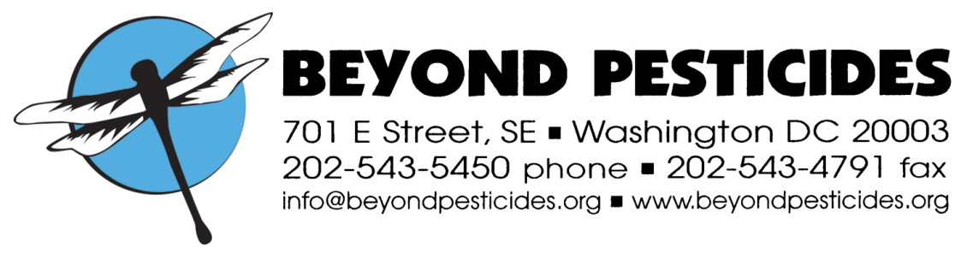

February, 2013

National Organic Standards Board
Spring 2013 Meeting
Portland, OR

Re. Polyoxin D Zinc Salt

These comments are submitted on behalf of Beyond Pesticides. Beyond Pesticides, founded in 1981 as a national, grassroots, membership organization that represents community-based organizations and a range of people seeking to bridge the interests of consumers, farmers and farmworkers, advances improved protections from pesticides and alternative pest management strategies that reduce or eliminate a reliance on pesticides. Our membership and network span the 50 states and groups around the world.

Beyond Pesticides agrees with the recommendation of the Crops Subcommittee to deny the petition for polyoxin D zinc salt (PDZ) as a fungicide. PDZ does not meet any of the OFPA criteria—for environmental and health impacts, compatibility with organic systems, or essentiality.

1. Polyoxin D zinc salt has impacts on beneficial organisms and may cause chromosomal mutations in mammals.
The mode of action of PDZ is inhibition of the enzyme chitin synthetase, which stops the growth of the target fungi. However, plant pathogenic fungi are not the only fungi in an organic system. The soil ecosystem depends on fungi for breaking down organic matter and supplying nutrients to plants. A broad spectrum fungicide thus attacks the very basis of the organic agroecosystem. It also endangers some biocontrol organisms. In addition, research reported in the Technical Report (TR) showed that PDZ inhibits the same target enzyme in cockroaches. Thus, we should assume until shown otherwise that it would inhibit chitin production in other insects, thus preventing the transformation from larvae to adults in lady beetles, for example.

In addition, we are not satisfied with EPA’s dismissal of the study it found acceptable that demonstrated highly significant increases in chromosomal aberrations in hamster cells treated with PDZ.

2. Polyoxin D zinc salt is incompatible with a system of organic and sustainable agriculture.
PDZ is an unnecessary (see below) synthetic input. It causes nontarget effects on beneficial organisms in the organic system. PDZ epitomizes the kind of input that is welcomed in integrated pest management (IPM) systems, but is incompatible with organic production. PDZ is welcomed in IPM because it is less toxic than many conventional fungicides and provides another “tool” in the IPM toolbox. It allows growers to cycle through more different chemicals, thus reducing the development and spread of resistance in pathogenic fungi. These are seen as very positive characteristics in systems that rely on chemical inputs for fertility and plant health. However, organic systems rely on the interactions of organisms in the agroecosystem to provide those things, and inputs must not endanger the web of relationships in that system.

3. Polyoxin D zinc salt is not essential.
As is pointed out in the TR and the material evaluation checklist, there are many alternatives to using PDZ, including “crop rotation, crop nutrient management practices, sanitation to remove disease vectors, selection of resistant species and varieties (where applicable) beneficial antagonistic bacteria, monitoring”—all important, but basic, organic practices.

Thus we urge the NOSB to reject the petition of polyoxin D zinc.

Thank you for your consideration of these comments.

Sincerely,

Terry Shistar, Ph.D.
Board member

